Tutorial No. __2_____

Title: Planning a web site

Batch: B1 Roll No.: 1914078 Tutorial No.: 2

Aim: To understand concept of planning
a website
___________________________________________________________________________
Resources needed: Internet Browser ___________________________________________________________________________

1. Choose topic for website
2. Describe content of website in detail
3. Prepare layout of web site
_______________________________________________________________________

Topic of Web site: Portfolio Site

_______________________________________________________________________
Content of Web site:
- Greetings and About Me
- My passion
- Portfolio of work
- Services/Skills
- Contact Me

________________________________________________________________________
Layout of Web site:
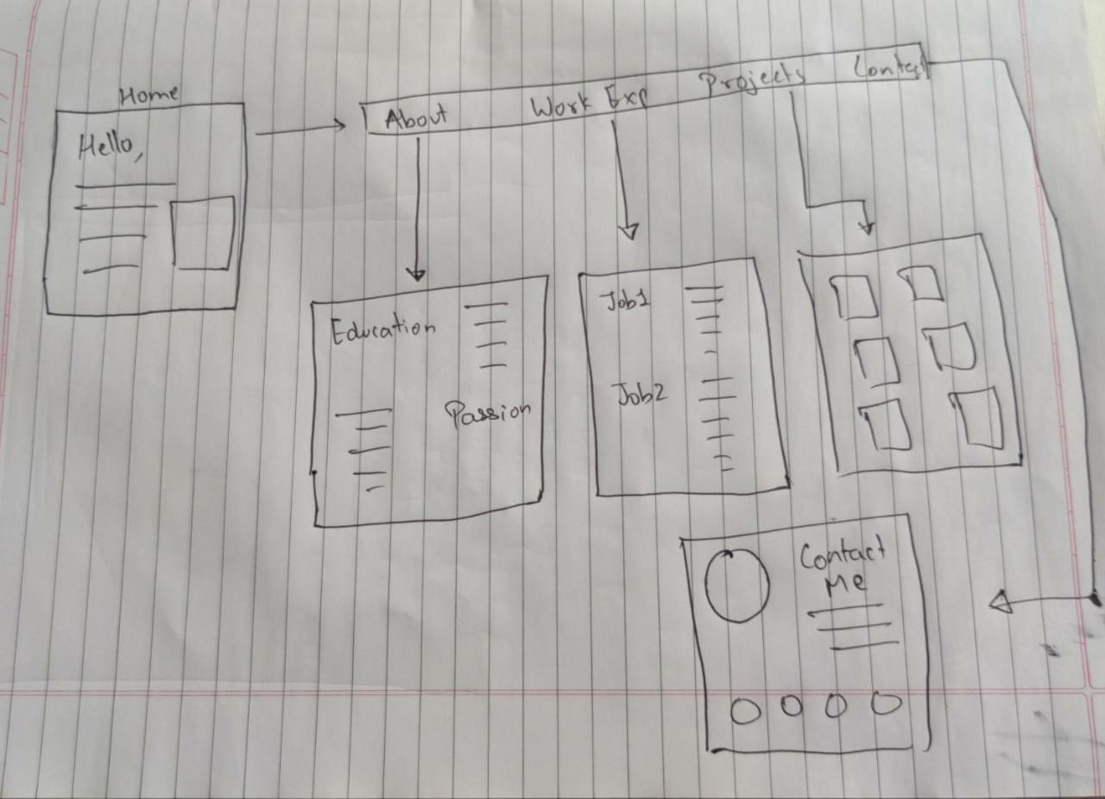

___________________________________________________________________________
Outcome: Comprehend basics of Web Technology

___________________________________________________________________________

Conclusion: We understood concept of planning a website

References: To be added by student.

